Data Structures and Object-Oriented Programming
110 Spring
National Yang Ming Chiao Tung University

Time: 110 minutes

Instructions:
- There are FIVE pages.
- There are TEN questions. You must answer all of them.
- You must use hand writing to write your answers on the answer sheets. You must sign your name and student ID on each answer sheet. Scan or take photos of the answer sheets. Upload all the scanned images or photos to E3 before deadline. The signed name and ID must be shown clearly on each scanned image or photo.
- You should assume that all the libraries are included properly for each question.
- CHEATING IS A SERIOUS MATTER. YOU WILL RECEIVE A SCORE OF ZERO and SERIOUS PENALTY IF YOU CHEAT.

Student Name: __________________________

Student ID: _____________________________

- Given the program, answer the following questions

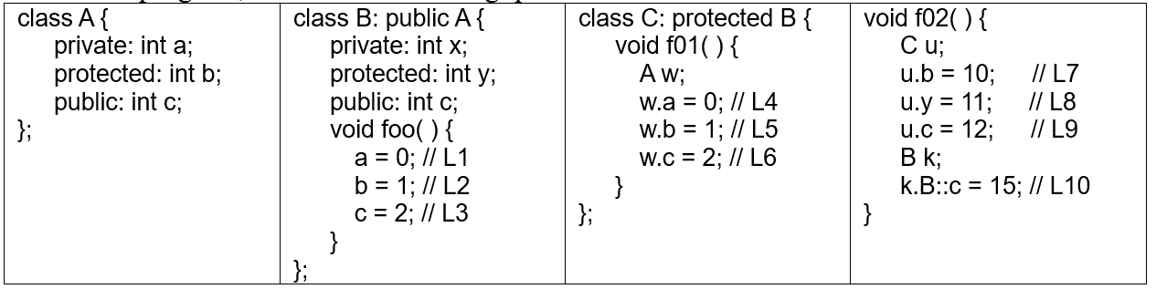
1 [(0.5+1)%x10] Function f02( ) is not a member function of classes A, B, and C. For each of the instructions at lines L1, L2, L3, …, L10, write down Yes if the instruction can be compiled successfully and explain why the line can be compiled; and otherwise write down No and explain why the line cannot be compiled.

2(a) [2+2+1%] Function main( ) is invoked. After each instruction is executed at lines L1, L2, and L3, what are the outputs at the line? If there is no output, write down No output. If a line has an error(s), write down Error and skip the line. The output order and format must be correct, e.g., including new lines, tab, empty lines, etc. Mark each invisible output.
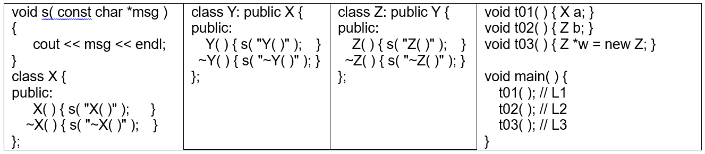

2(b) [(1+1)+(1+1)+(0.5+0.5)%] foo( ) is invoked. Answer the question(s) based on the following code fragment. After each instruction is executed at lines L1, L2, and L3, what is/are the output(s) at the line? Explain how the result is obtained for each line.
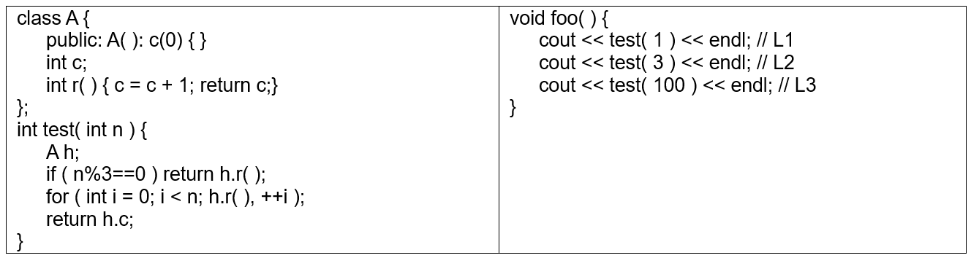

3 Given the following code fragment:

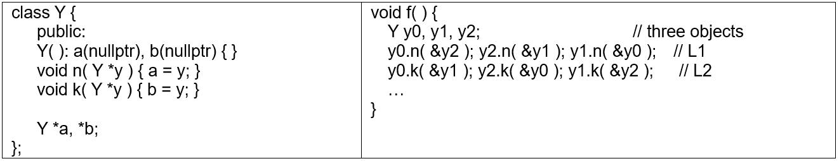

3. Invoke f( ). After L1 and L2 are executed, answer the following questions.
3(a) [1%x3] Which object does each of the pointers, y0.a, y1.a, and y2.b, point to?
3(b) [2%] Which object does the pointer y0.b->b->a->a point to? If the pointer does not point to any object, write down No.
4. Given the following code fragment:
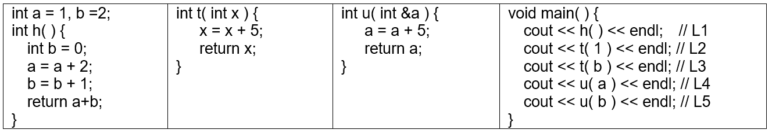
4 [2%x5] Function main( ) is invoked. After each instruction is executed at lines L1, L2,…, and L5, what is/are the output(s) at the line?

5. Given the following code fragment:
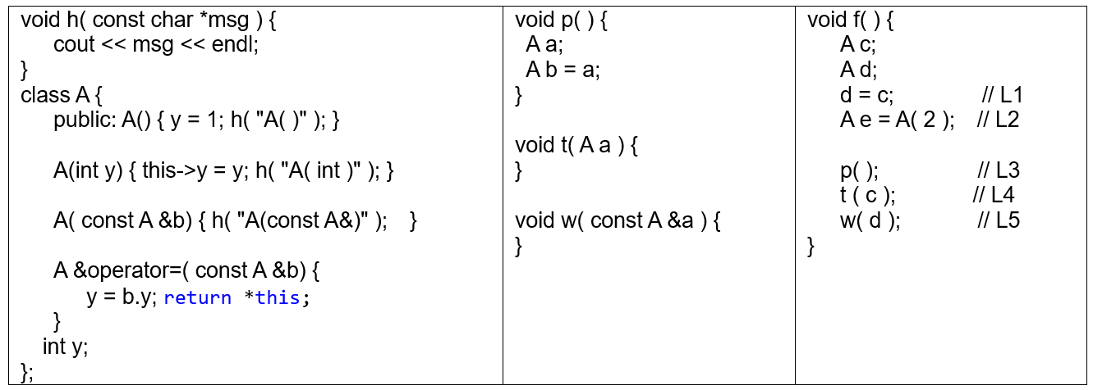
Function f( ) is invoked. If there is no output, write down No output. If a line has an error(s), write down Error and skip the line. The output order and format must be correct, e.g., including new lines, tab, etc. Mark each invisible output.
5 [2%x5] For each of the following lines L1, L2, L3, L4, and L5, after the line is executed, what is/are the output(s) at the line?

6. Given the program fragment, answer the following questions.
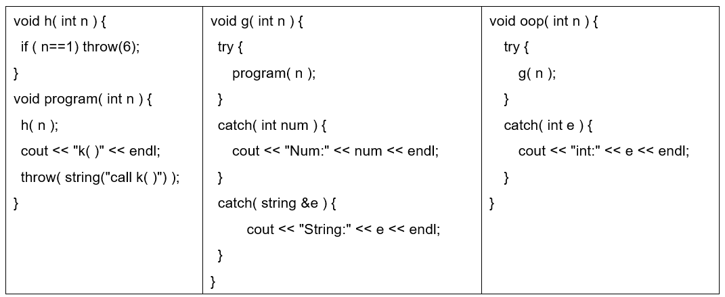

If there is no output, write down no output. The output order and format must be correct, e.g., including new lines, tab, etc. Mark each invisible output.
6(a) [3%] Invoke oop(1). Write down the output after the function call is executed.
6(b) [2%] Invoke oop(2). Write down the output after the function call is executed.

7. Function f( ) is invoked.
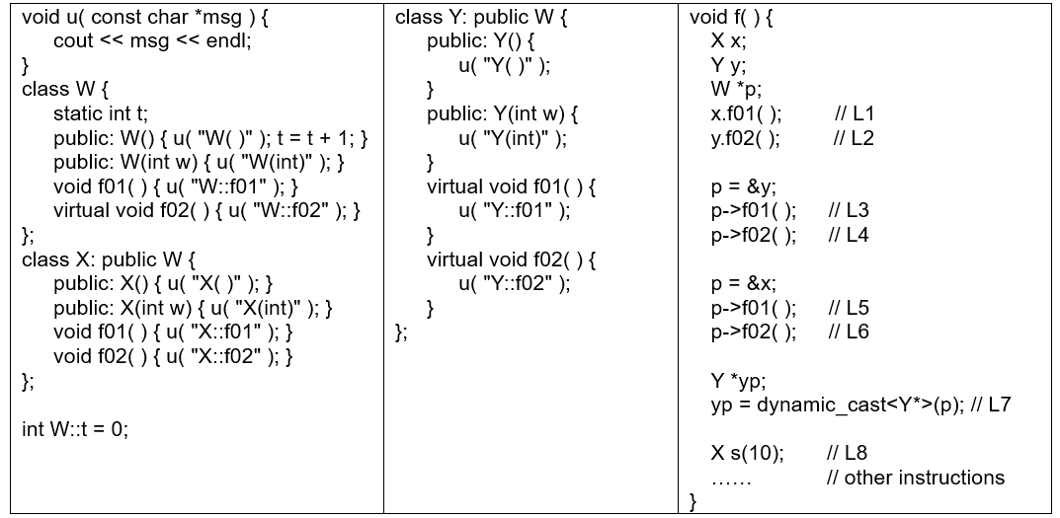
If there is no output, write down No output. If a line has an error(s), write down Error and skip the line. The output order and format must be correct, e.g., including new lines, tab, etc. Mark each invisible output.
7(a) [2%x6] For each of the following lines L1, L2, L3, L4, L5, and L6 after the line is executed, what is/are the output?
7(b) [1+1%] At L7, why is dynamic_cast used to convert pointer p to a pointer of type Y*? After L7 is executed, what does yp point to?
7(c) [0.5%] At line L8, after L8 is executed, what is/are the output(s) at the line?
7(d) [0.5%] After L8 is executed, what is the value of W::t?

8. Function u( ) is invoked.
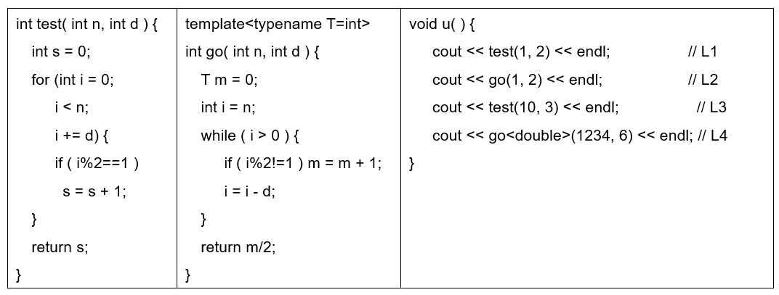
If there is no output, write down No output. If a line has an error(s), write down Error and skip the line. The output order and format must be correct, e.g., including new lines, tab, etc. Mark each invisible output.
8(a) [2%x3] For each of the following lines L1, L2, and L3 after the line is executed, what is/are the output at the line?
8(b) [0.5+0.5%] After line L4 is executed, what is/are the output(s) at the line? Explain how the result is obtained.

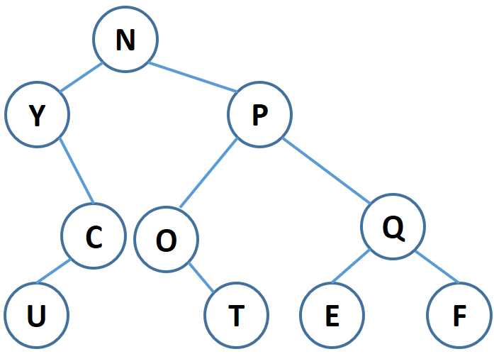
9. Given the binary tree on the right side, answer the following questions:
9(a) [2%] What is the level-order traversal output?
9(b) [2%] What is the post-order traversal output?
9(c) [2%] What is the in-order traversal output?
9(d) [2%] What is the pre-order traversal output?

9(e) [5%] There is a binary tree. The postorder traversal result is ENJOYFBXWZ and the inorder traversal result is EJNFOYZXBW. Construct the binary tree.

10(a) [1+1%] Write down in big-O notation for each of the following expressions:
i) log(k*n³) + n log n and ii) n² + n*10²⁰²². Here, n is the input size.

10(b1) [2%] A stack is empty. The following five numbers are added to the stack one by one:
1, 2, 5, 6, and 7. Now the pop operation is performed. Which number is popped?
10(b2) [2%] If the pop operations are called repeatedly until there is only one number in the stack, what is the number?

10(c1) [1%] A queue is empty. The following five numbers are added to the queue one by one:
1, 2, 5, 6, and 7. Now the pop operation is performed. Which number is popped?
10(c2) [1%] If the pop operations are called repeatedly until there is only one number in the queue, what is the number?

10(d) [1%] Construct a max heap for the following five numbers: 1, 2, 5, 6, 7. The root must be 7.

10(e) [1%] Construct a red-black tree for the following five numbers: 1, 2, 5, 6, 7. The root must be 2. You must use colored nodes definition. The numbers on the left subtree of a node must be smaller than the node. Mark down the color of each node clearly. The tree must have external nodes. If there does not exist a red-black tree for the numbers, write down No. Also, explain why there does not exist such a red-black tree.

;END EXAM

